**OOPS**

1. Data Hiding
2. Abstraction
3. Encapsulation
4. Tightly Encapsulated Class
5. IS-A Relationship
6. HAS-A Relationship
7. Method Signature
8. Overloading
9. Overriding
10. Method Hiding
11. Static Control Flow
12. Instance Control Flow
13. Constructors
14. Coupling
15. Cohesion
16. Object Type Casting

**Data Hiding:**

* Our internal data should not go out directly that is outside person can’t access our internal data directly.
* By using private modifier we can implement data hiding.

**Example:**

class Account

{

private double balance;

......................;

......................;

}

* The main advantage of data hiding is security.

**Note:** recommended modifier for data members is private.

**Abstraction:**

* Hide internal implementation and just highlight the set of services, is called abstraction.
* By using abstract classes and interfaces we can implement abstraction.

**Example:**

* By using ATM GUI screen bank people are highlighting the set of services what they are offering without highlighting internal implementation.
* The main advantages of Abstraction are:

1. We can achieve security as we are not highlighting our internal implementation.
2. Enhancement will become very easy because without effecting end user we can able to perform any type of changes in our internal system.
3. It provides more flexibility to the end user to use system very easily.
4. It improves maintainability of the application.

**Encapsulation:**

* It is the process of Encapsulating data and corresponding methods into a single module.
* If any java class follows data hiding and abstraction such type of class is said to be encapsulated class.

**Encapsulation=Datahiding+Abstraction**

**Example:**

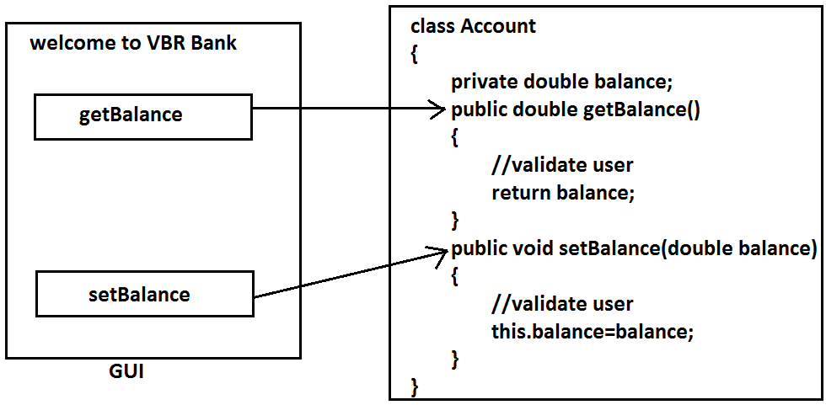

* In encapsulated class we have to maintain getter and setter methods for every data member.
* The main advantages of encapsulation are:

1. We can achieve security.
2. Enhancement will become very easy.
3. It improves maintainability of the application.
4. It provides flexibility to the user to use system very easily.

* The main disadvantage of encapsulation is it increases length of the code and slows down execution.

**Tightly encapsulated class:**

* A class is said to be tightly encapsulated if and only if every variable of that class declared as private whether the variable has getter and setter methods are not and whether these methods declared as public or not, not required to check.

**Example:**

class Account

{

private double balance;

public double getBalance()

{

return balance;

}

}

**Which of the following classes are tightly encapsulated?**

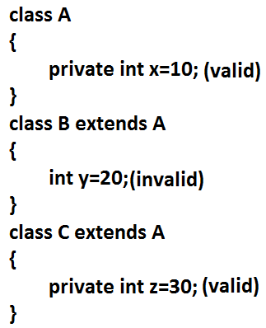

**Which of the following classes are tightly encapsulated?**

class A

{

int x=10;

}

class B extends A

{

private int y=20;

}

class C extends B

{

private int z=30;

}

**Note:** if the parent class is not tightly encapsulated then no child class is tightly encapsulated.

**IS-A Relationship(inheritance):**

1. Also known as inheritance.
2. By using extends keywords we can implement IS-A relationship.
3. The main advantage of IS-A relationship is reusability.

**Example:**

class Parent

{

public void methodOne()

{}

}

class Child extends Parent

{

public void methodTwo()

{}

}

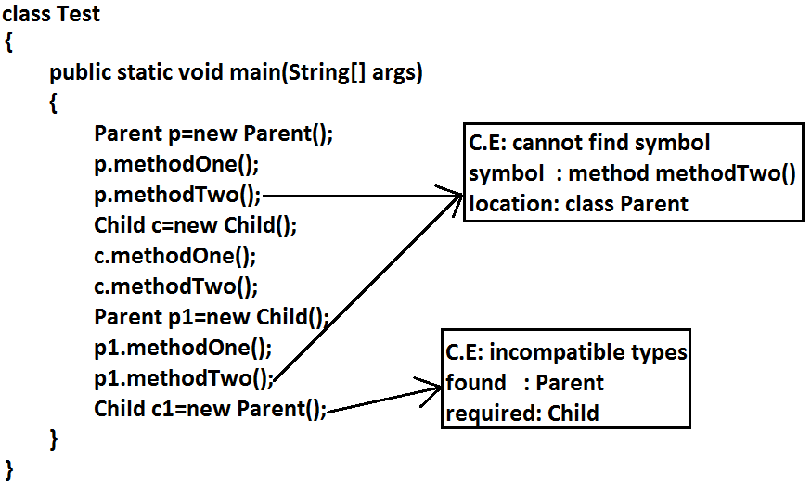

**Conclusion:**

1. Whatever the parent has by default available to the child but whatever the child has by default not available to the parent. Hence on the child reference we can call both parent and child class methods. But on the parent reference we can call only methods available in the parent class and we can’t call child specific methods.
2. Parent class reference can be used to hold child class object but by using that reference we can call only methods available in parent class and child specific methods we can’t call.
3. Child class reference cannot be used to hold parent class object.

**Example:**

* The common methods which are required for housing loan, vehicle loan, personal loan and education loan we can define into a separate class in parent class loan. So that automatically these methods are available to every child loan class.

**Example:**

class Loan

{

//common methods which are required for any type of loan.

}

class HousingLoan extends Loan

{

//Housing loan specific methods.

}

class EducationLoan extends Loan

{

//Education Loan specific methods.

}

* For all java classes the most commonly required functionality is define inside object class hence object class acts as a root for all java classes.
* For all java exceptions and errors the most common required functionality defines inside Throwable class hence Throwable class acts as a root for exception hierarchy.

**Diagram:**

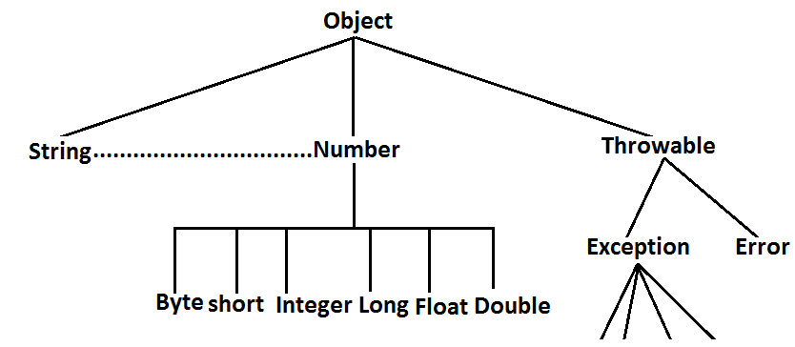

**Multiple inheritance:**

* Having more than one Parent class at the same level is called multiple inheritance.

**Example:**

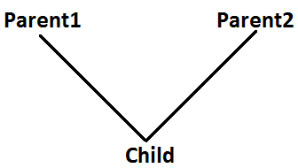

* Any class can extends only one class at a time and can’t extends more than one class simultaneously hence java won’t provide support for multiple inheritance.

**Example:**

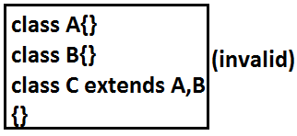

* But an interface can extends any no. Of interfaces at a time hence java provides support for multiple inheritance through interfaces.

**Example:**

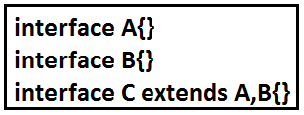

* If our class doesn’t extends any other class then only our class is the direct child class of object.

**Example:**

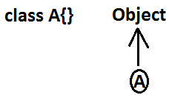

* If our class extends any other class then our class is not direct child class of object.

**Example 1:**

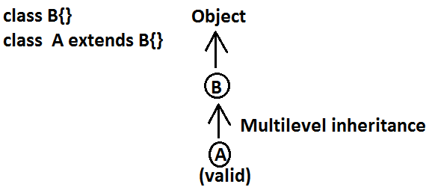

**Example 2:**

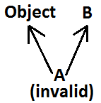

**Why java won’t provide support for multiple inheritance?**

* There may be a chance of raising ambiguity problems.

**Example:**

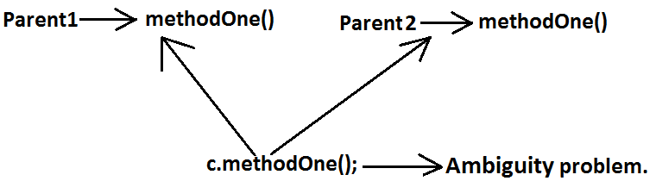

**Why ambiguity problem won’t be there in interfaces?**

* Interfaces having dummy declarations and they won’t have implementations hence no ambiguity problem.

**Example:**

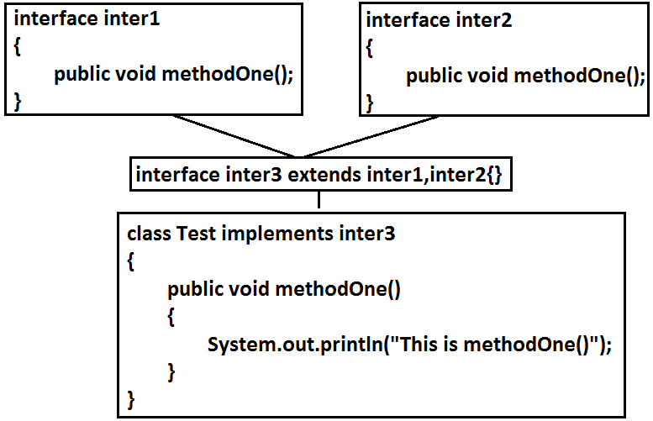

**Cyclic inheritance:**

* Cyclic inheritance is not allowed in java.

**Example 1:**

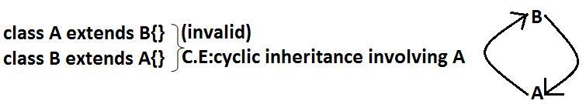

**Example 2:**



**HAS-A relationship:**

1. HAS-A relationship is also known as composition (or) aggregation.
2. There is no specific keyword to implement hAS-A relationship but mostly we can use new operator.
3. The main advantage of HAS-A relationship is reusability.

**Example:**

class Engine

{

//engine specific functionality

}

class Car

{

Engine e=new Engine();

//........................;

//........................;

//........................;

}

* Class Car HAS-A engine reference.
* HAS-A relationship increases dependency between the components and creates maintains problems.

**Composition vs Aggregation:**

**Composition:**

* Without existing container object if there is no chance of existing contained objects then the relationship between container object and contained object is called composition which is a strong association.

**Example:**

* University consists of several departments whenever university object destroys automatically all the department objects will be destroyed that is without existing university object there is no chance of existing dependent object hence these are strongly associated and this relationship is called composition.

**Example:**

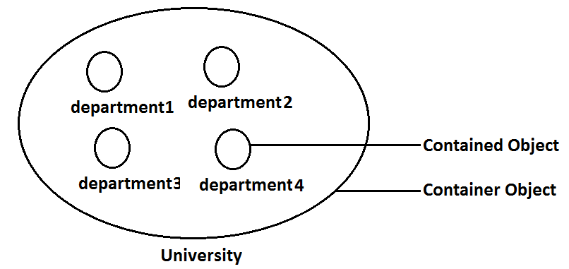

**Aggregation:**

* Without existing container object if there is a chance of existing contained objects such type of relationship is called aggregation. In aggregation objects have weak association.

**Example:**

* Within a department there may be a chance of several professors will work whenever we are closing department still there may be a chance of existing professor object without existing department object the relationship between department and professor is called aggregation where the objects having weak association.

**Example:**

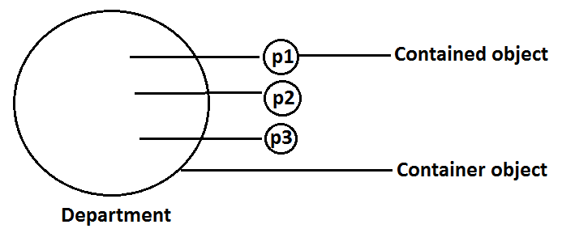

**Method signature:** In java method signature consists of name of the method followed by argument types.

**Example:**

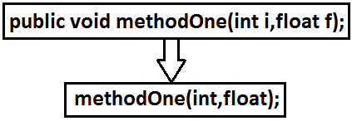

* In java return type is not part of the method signature.
* Compiler will use method signature while resolving method calls.
* Within the same class we can’t take 2 methods with the same signature otherwise we will get compile time error.

**Example:**

public void methodOne()

{}

public int methodOne()

{

return 10;

}

**Output:**

Compile time error

methodOne() is already defined in Test

**Overloading:**

* Two methods are said to be overload if and only if both having the same name but different argument types.
* In ‘C’ language we can’t take 2 methods with the same name and different types. If there is a change in argument type compulsory we should go for new method name.

**Example:**

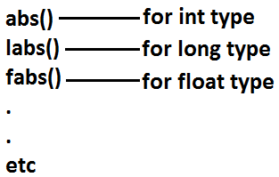

* Lack of overloading in “C” increases complexity of the programming.
* But in java we can take multiple methods with the same name and different argument types.

**Example:**

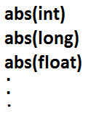

* Having the same name and different argument types is called method overloading.
* All these methods are considered as overloaded methods.
* Having overloading concept in java reduces complexity of the programming.

**Example:**

class Test

{

public void methodOne()

{

System.out.println("no-arg method");

}

public void methodOne(int i)

{

System.out.println("int-arg method"); **overloaded methods**

}

public void methodOne(double d)

{

System.out.println("double-arg method");

}

public static void main(String[] args)

{

Test t=new Test();

t.methodOne();//no-arg method

t.methodOne(10);//int-arg method

t.methodOne(10.5);//double-arg method

}

}

* In overloading compiler is responsible to perform method resolution(decision) based on the reference type. Hence overloading is also considered as compile time polymorphism(or) static ()early biding.

**Case 1: Automatic promotion in overloading.**

* In overloading if compiler is unable to find the method with exact match we won’t get any compile time error immediately.
* 1st compiler promotes the argument to the next level and checks whether the matched method is available or not if it is available then that method will be considered if it is not available then compiler promotes the argument once again to the next level. This process will be continued until all possible promotions still if the matched method is not available then we will get compile time error. This process is called automatic promotion in overloading.
* The following are various possible automatic promotions in overloading.

**Diagram:**

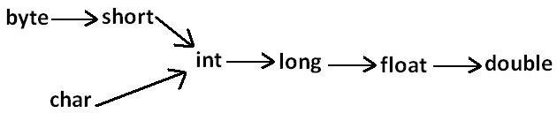

**Example:**

class Test

{

public void methodOne(int i)

{

System.out.println("int-arg method");

}

public void methodOne(float f) **overloaded methods**

{

System.out.println("float-arg method");

}

public static void main(String[] args)

{

Test t=new Test();

//t.methodOne('a');//int-arg method

//t.methodOne(10l);//float-arg method

t.methodOne(10.5);//C.E:cannot find symbol

}

}

**Case 2:**

class Test

{

public void methodOne(String s)

{

System.out.println("String version");

}

public void methodOne(Object o) **Both methods are said to**

**be overloaded methods.**

{

System.out.println("Object version");

}

public static void main(String[] args)

{

Test t=new Test();

t.methodOne("bhaskar");//String version

t.methodOne(new Object());//Object version

t.methodOne(null);//String version

}

}

* In overloading Child will always get high priority then Parent.

**Case 3:**

class Test

{

public void methodOne(String s)

{

System.out.println("String version");

}

public void methodOne(StringBuffer s)

{

System.out.println("StringBuffer version");

}

public static void main(String[] args)

{

Test t=new Test();

t.methodOne("subbu");//String version

t.methodOne(new StringBuffer("bhaskar"));//StringBuffer version

}

}

**Output:**

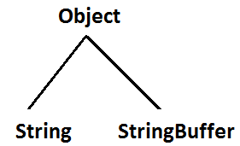

**Case 4:**

class Test

{

public void methodOne(int i,float f)

{

System.out.println("int-float method");

}

public void methodOne(float f,int i)

{

System.out.println("float-int method");

}

public static void main(String[] args)

{

Test t=new Test();

t.methodOne(10,10.5f);//int-float method

t.methodOne(10.5f,10);//float-int method

t.methodOne(10,10);//C.E:reference to methodOne is ambiguous, both method methodOne(int,float) in Test and method methodOne(float,int) in Test match

t.methodOne(10.5f,10.5f);//C.E:cannot find symbol

}

}

**Case 5:**

class Test

{

public void methodOne(int i)

{

System.out.println("general method");

}

public void methodOne(int...i)

{

System.out.println("var-arg method");

}

public static void main(String[] args)

{

Test t=new Test();

t.methodOne();//var-arg method

t.methodOne(10,20);//var-arg method

t.methodOne(10);//general method

}

}

* In general var-arg method will get less priority that is if no other method matched then only var-arg method will get chance for execution it is almost same as default case inside switch.

**Case 6:**

class Animal{}

class Monkey extends Animal{}

class Test

{

public void methodOne(Animal a)

{

System.out.println("Animal version");

}

public void methodOne(Monkey m)

{

System.out.println("Monkey version");

}

public static void main(String[] args)

{

Test t=new Test();

Animal a=new Animal();

t.methodOne(a);//Animal version

Monkey m=new Monkey();

t.methodOne(m);//Monkey version

Animal a1=new Monkey();

t.methodOne(a1);//Animal version

}

}

* In overloading method resolution is always based on reference type and runtime object won’t play any role in overloading.

**Overriding:**

* Whatever the Parent has by default available to the Child through inheritance, if the Child is not satisfied with Parent class method implementation then Child is allow to redefine that Parent class method in Child class in its own way this process is called overriding.
* The Parent class method which is overridden is called overridden method.
* The Child class method which is overriding is called overriding method.

**Example 1:**

class Parent

{

public void property()

{

System.out.println("cash+land+gold");

}

public void marry()

{

System.out.println("subbalakshmi"); **overridden method**

}

}

class Child extends Parent **overriding**

{

public void marry()

{

System.out.println("Trisha/nayanatara/anushka"); **overriding method**

}

}

class Test

{

public static void main(String[] args)

{

Parent p=new Parent();

p.marry();//subbalakshmi(parent method)

Child c=new Child();

c.marry();//Trisha/nayanatara/anushka(child method)

Parent p1=new Child();

p1.marry();//Trisha/nayanatara/anushka(child method)

}

}

* In overriding method resolution is always takes care by JVM based on runtime object hence overriding is also considered as runtime polymorphism or dynamic polymorphism or late binding.
* The process of overriding method resolution is also known as dynamic method dispatch.

**Note:** In overriding runtime object will play the role and reference type is dummy.

**Rules for overriding:**

* In overriding method names and arguments must be same. That is method signature must be same.
* Until 1.4 version the return types must be same but from 1.5 version onwards co-variant return types are allowed.
* According to this Child class method return type need not be same as Parent class method return type its Child types also allowed.

**Example:**

class Parent

{

public Object methodOne()

{

return null;

}

}

class Child extends Parent

{

public String methodOne()

{

return null;

}

}

* It is valid in “1.5” but invalid in “1.4”.

**Diagram:**

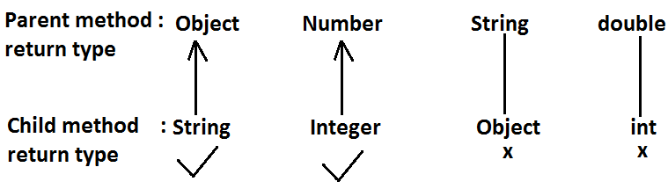

* Co-variant return type concept is applicable only for object types but not for primitives.
* Private methods are not visible in the Child classes hence overriding concept is not applicable for private methods. Based on own requirement we can declare the same Parent class private method in child class also. It is valid but not overriding.

**Example:**

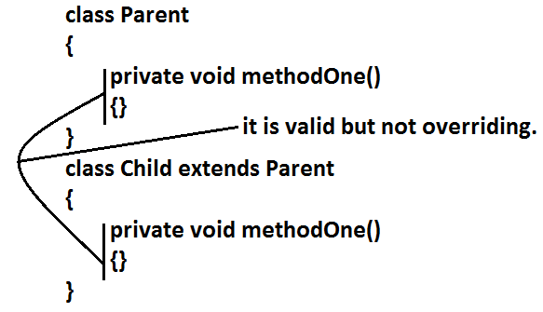

* Parent class final methods we can’t override in the Child class.

**Example:**

class Parent

{

public final void methodOne()

{}

}

class Child extends Parent

{

public void methodOne()

{}

}

**Output:**

Compile time error.

Child.java:8: methodOne() in Child cannot override methodOne() in Parent; overridden method is final

* Parent class non final methods we can override as final in child class. We can override native methods in the child classes.
* We should override Parent class abstract methods in Child classes to provide implementation.

**Example:**

abstract class Parent

{

public abstract void methodOne();

}

class Child extends Parent

{

public void methodOne()

{}

}

**Diagram:**

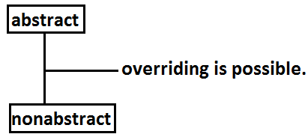

* We can override Parent class non abstract method as abstract to stop availability of Parent class method implementation to the Child classes.

**Example:**

class Parent

{

public void methodOne()

{}

}

abstract class Child extends Parent

{

public abstract void methodOne();

}

* Synchronized, strictfp, modifiers won’t keep any restrictions on overriding.

**Diagram:**

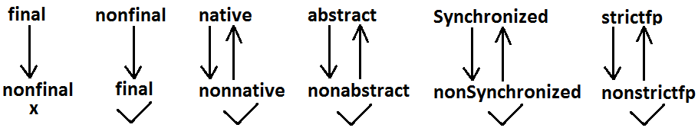

* While overriding we can’t reduce the scope of access modifier.

**Example:**

class Parent

{

public void methodOne()

{}

}

class Child extends Parent

{

protected void methodOne()

{}

}

**Output:**

Compile time error

methodOne() in Child cannot override methodOne() in Parent; attempting to assign weaker access privileges; was public

**Diagram:**

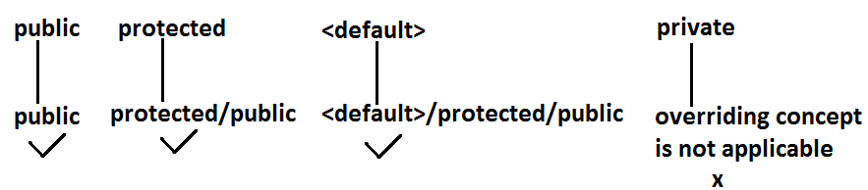

**Checked Vs Un-checked Exceptions:**

* The exceptions which are checked by the compiler for smooth execution of the program at runtime are called checked exceptions.
* The exceptions which are not checked by the compiler are called un-checked exceptions.
* RuntimeException and its child classes, Error and its child classes are unchecked except these the remaining are checked exceptions.

**Diagram:**

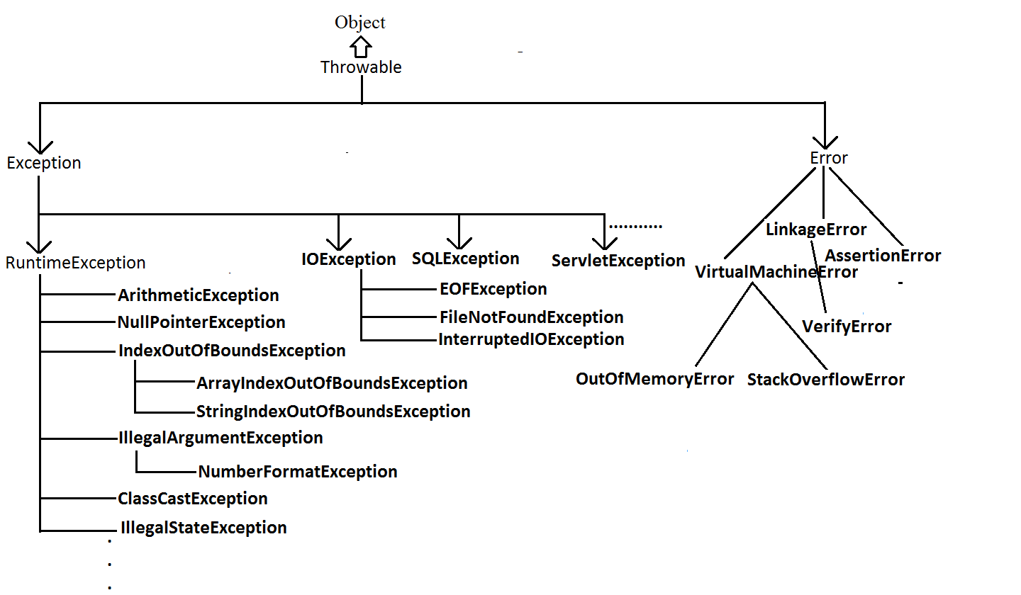

**Rule:** **While overriding if the child class method throws any checked exception compulsory the parent class** **method should throw the same checked exception or its parent otherwise we will get compile time error.**

* But there are no restrictions for un-checked exceptions.

**Example:**

class Parent

{

public void methodOne()

{}

}

class Child extends Parent

{

public void methodOne()throws Exception

{}

}

**Output:**

Compile time error

methodOne() in Child cannot override methodOne() in Parent; overridden method does not throw java.lang.Exception

**Examples:**

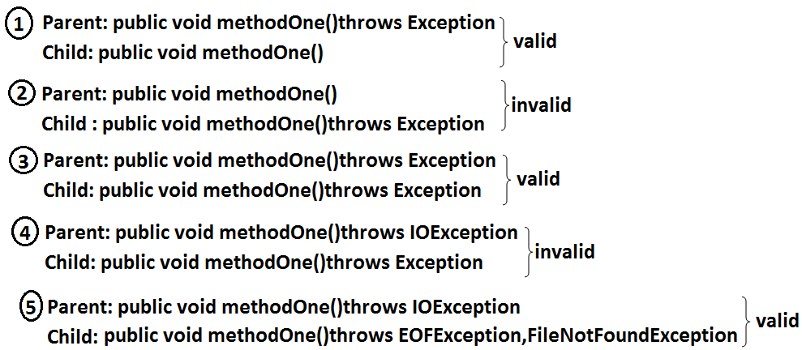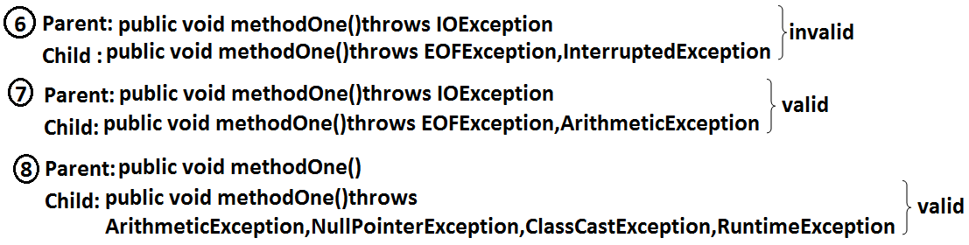**Overriding with respect to static methods:**

**Case 1:**

* We can’t override a static method as non static.

**Example:**

class Parent

{

public static void methodOne()//**here static methodOne() method is a class level**

{}

}

class Child extends Parent

{

public void methodOne()//**here** **methodOne() method is a object level hence we can’t** **override methodOne() method**

{}

}

**Case 2:**

* Similarly we can’t override a non static method as static.

**Case 3:**

class Parent

{

public static void methodOne()

{}

}

class Child extends Parent

{

public static void methodOne()

{}

}

* It is valid. It seems to be overriding concept is applicable for static methods but it is not overriding it is met1hod hiding.

**METHOD HIDING**

* All rules of method hiding are exactly same as overriding except the following differences.

|  |  |
| --- | --- |
| **Overriding** | **Method hiding** |
| 1. Both Parent and Child class methods should be non static. | 1. Both Parent and Child class methods should be static. |
| 2. Method resolution is always takes care by JVM based on runtime object. | 2. Method resolution is always takes care by compiler based on reference type. |
| 3. Overriding is also considered as runtime polymorphism (or) dynamic polymorphism (or) late binding. | 3. Method hiding is also considered as compile time polymorphism (or) static polymorphism (or) early biding. |

**Example:**

class Parent

{

public static void methodOne()

{

System.out.println("parent class");

}

}

class Child extends Parent

{

public static void methodOne()

{

System.out.println("child class");

}

}

class Test

{

public static void main(String[] args)

{

Parent p=new Parent();

p.methodOne();//parent class

Child c=new Child();

c.methodOne();//child class

Parent p1=new Child();

p1.methodOne();//parent class

}

}

**Note:** If both Parent and Child class methods are non static then it will become overriding and method resolution is based on runtime object. In this case the output is

Parent class

Child class

Child class

**Overriding with respect to Var arg methods:**

* A var arg method should be overridden with var-arg method only. If we are trying to override with normal method then it will become overloading but not overriding.

**Example:**

class Parent

{

public void methodOne(int... i)

{

System.out.println("parent class");

}

}

class Child extends Parent **overloading but not overriding.**

{

public void methodOne(int i)

{

System.out.println("child class");

}

}

class Test

{

public static void main(String[] args)

{

Parent p=new Parent();

p.methodOne(10);//parent class

Child c=new Child();

c.methodOne(10);//child class

Parent p1=new Child();

p1.methodOne(10);//parent class

}

}

* In the above program if we replace child class method with var arg then it will become overriding. In this case the output is

Parent class

Child class

Child class

**Overriding with respect to variables:**

* Overriding concept is not applicable for variables.
* Variable resolution is always takes care by compiler based on reference type.

**Example:**

class Parent

{

int x=888;

}

class Child extends Parent

{

int x=999;

}

class Test

{

public static void main(String[] args)

{

Parent p=new Parent();

System.out.println(p.x);//888

Child c=new Child();

System.out.println(c.x);//999

Parent p1=new Child();

System.out.println(p1.x);//888

}

}

**Note:** In the above program Parent and Child class variables, whether both are static or non static whether one is static and the other one is non static there is no change in the answer.

**Differences between overloading and overriding?**

|  |  |  |
| --- | --- | --- |
| **Property** | **Overloading** | **Overriding** |
| 1. Method names | 1. Must be same. | 1. Must be same. |
| 1. Argument type | 1. Must be different(at least order) | 1. Must be same including order. |
| 1. Method signature | 1. Must be different. | 1. Must be same. |
| 1. Return types | 1. No restrictions. | 1. Must be same until 1.4v but from 1.5v onwards we can take co-variant return types also. |
| 1. private,static,final methods | 1. Can be overloaded. | 1. Can not be overridden. |
| 1. Access modifiers | 1. No restrictions. | 1. Weakering/reducing is not allowed. |
| 1. Throws clause | 1. No restrictions. | 1. If child class method throws any checked exception compulsory parent class method should throw the same checked exceptions or its parent but no restrictions for un-checked exceptions. |
| 1. Method resolution | 1. Is always takes care by compiler based on referenced type. | 1. Is always takes care by JVM based on runtime object. |
| 1. Also known as | 1. Compile time polymorphism (or) static(or)early binding. | 1. Runtime polymorphism (or) dynamic (or) late binding. |

**Note:**

1. In overloading we have to check only method names (must be same) and arguments (must be different) the remaining things like return type extra not required to check.
2. But In overriding we should compulsory check everything like method names, arguments, return types, throws keyword, modifiers etc.

* **Consider the method in parent class**

**Parent: public void methodOne(int i)throws IOException**

* In the child class which of the following methods we can take.

1. public void methodOne(int i)//valid(overriding)
2. private void methodOne()throws Exception//valid(overloading)
3. public native void methodOne(int i);//valid(overriding)
4. public static void methodOne(double d)//valid(overloading)
5. public static void methodOne(int i)

**Compile time error**

1. methodOne(int) in Child cannot override methodOne(int) in Parent; overriding method is static
2. public static abstract void methodOne(float f)

**Compile time error**

1. illegal combination of modifiers: abstract and static
2. Child is not abstract and does not override abstract method methodOne(float) in Child

**Polymorphism:** Same name with different forms is the concept of polymorphism.

**Example 1:** We can use same abs() method for int type, long type, float type etc.

**Example:**

1. abs(int)
2. abs(long)
3. abs(float)

**Example 2:** We can use the same List reference to hold ArrayList object, LinkedList object, Vector object, or Stack object.

**Example:**

1. List l=new ArrayList();
2. List l=new LinkedList();
3. List l=new Vector();
4. List l=new Stack();

**Diagram:**

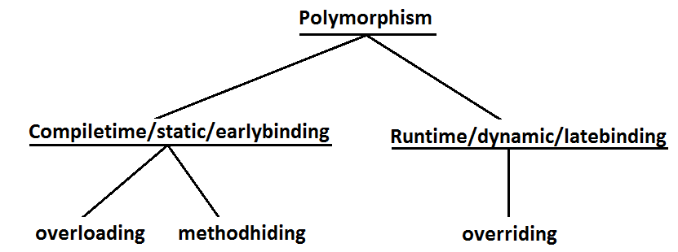

**Diagram:**

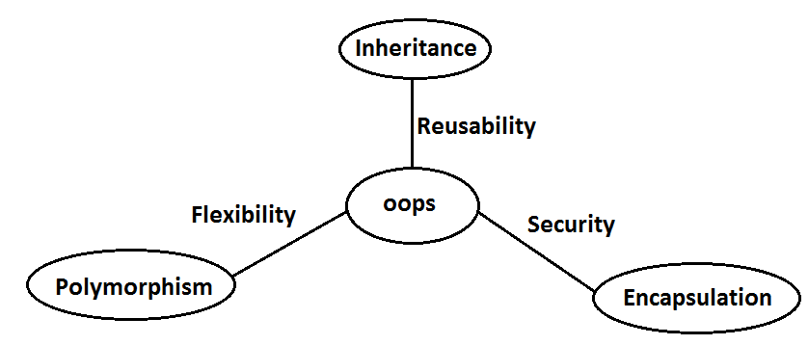

1. Inheritance talks about reusability.
2. Polymorphism talks about flexibility.
3. Encapsulation talks about security.

**Beautiful definition of polymorphism:**

* A boy starts love with the word friendship, but girl ends love with the same word friendship, word is the same but with different attitudes. This concept is nothing but polymorphism.

**Constructors**

* Object creation is not enough compulsory we should perform initialization then only the object is in a position to provide the response properly.
* Whenever we are creating an object some piece of the code will be executed automatically to perform initialization of an object this piece of the code is nothing but constructor.
* Hence the main objective of constructor is to perform initialization of an object.

**Example:**

class Student

{

String name;

int rollno;

Student(String name,int rollno)

{

this.name=name; **Constructor**

this.rollno=rollno;

}

public static void main(String[] args)

{

Student s1=new Student("vijayabhaskar",101);

Student s2=new Student("bhaskar",102);

}

}

**Diagram:**

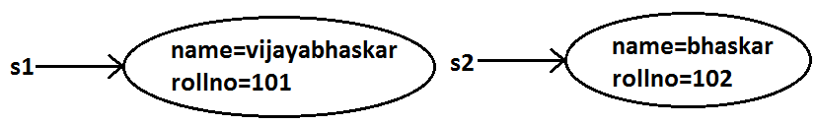

**Constructor Vs instance block:**

* Both instance block and constructor will be executed automatically for every object creation but instance block 1st followed by constructor.
* The main objective of constructor **is to perform** **initialization of an object**.
* Other than initialization **if we want to perform any activity for every object creation we have to define** **that activity inside instance block**.
* Both concepts having different purposes hence replacing one concept with another concept is not possible.
* Constructor can take arguments but instance block can’t take any arguments **hence we can’t replace constructor concept with instance block**.
* Similarly we can’t replace instance block purpose with constructor.

**Demo program to track no of objects created for a class:**

class Test

{

static int count=0;

{

count++; **instance block**

}

Test()

{}

Test(int i)

{}

public static void main(String[] args)

{

Test t1=new Test();

Test t2=new Test(10);

Test t3=new Test();

System.out.println(count);//3

}

}

**Rules to write constructors:**

1. Name of the constructor and name of the class must be same.
2. Return type concept is not applicable for constructor even void also by mistake if we are declaring the return type for the constructor we won’t get any compile time error and runtime error compiler simply treats it as a method.

**Example:**

class Test

{

void Test() **it is not a constructor and it is a method**

{}

}

1. It is legal (but stupid) to have a method whose name is exactly same as class name.
2. The only applicable modifiers for the constructors are **public, default, private, protected**.
3. If we are using any other modifier we will get compile time error.

**Example:**

class Test

{

static Test()

{}

}

**Output:**

Modifier static not allowed here

**Default constructor:**

* For every class in java including abstract classes also constructor concept is applicable.
* If we are not writing at least one constructor then compiler will generate default constructor.
* If we are writing at least one constructor then compiler won’t generate any default constructor. Hence every class contains either compiler generated constructor (or) programmer written constructor but not both simultaneously.

**Prototype of default constructor:**

1. It is always no argument constructor.
2. The access modifier of the default constructor is same as class modifier. (This rule is applicable only for public and default).
3. Default constructor contains only one line. **super();** it is a no argument call to super class constructor.

|  |  |
| --- | --- |
| **Programmers code** | **Compiler generated code** |
| class Test  {} | class Test  {  Test()  {  super();  }  } |
| public class Test  {} | public class Test  {  public Test()  {  super();  }  } |
| class Test  {  void Test(){}  } | class Test  {  Test()  {  super();  }  void Test()  {}  } |
| class Test  {  Test(int i)  {}  } | class Test  {  Test(int i)  {  super();  }  } |
| class Test  {  Test()  {  super();  }  } | class Test  {  Test()  {  super();  }  } |
| class Test  {  Test(int i)  {  this();  }  Test()  {}  } | class Test  {  Test(int i)  {  this();  }  Test()  {  super();  }  } |

**super() vs this():**

* The 1st line inside every constructor should be either super() or this() if we are not writing anything compiler will always generate super().

**Case 1:** We have to take super() (or) this() only in the 1st line of constructor. If we are taking anywhere else we will get compile time error.

**Example:**

class Test

{

Test()

{

System.out.println("constructor");

super();

}

}

**Output:**

Compile time error.

Call to super must be first statement in constructor

**Case 2:** We can use either super() (or) this() but not both simultaneously.

**Example:**

class Test

{

Test()

{

super();

this();

}

}

**Output:**

Compile time error.

Call to this must be first statement in constructor

**Case 3:** We can use super() (or) this() only inside constructor. If we are using anywhere else we will get compile time error.

**Example:**

class Test

{

public void methodOne()

{

super();

}

}

**Output:**

Compile time error.

Call to super must be first statement in constructor

* That is we can call a constructor directly from another constructor only.

**Diagram:**

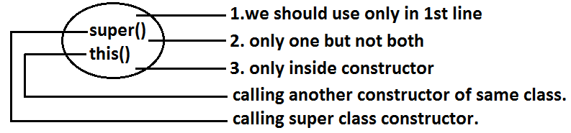

**Example:**

|  |  |
| --- | --- |
| **super(),this()** | **super, this** |
| 1. These are constructors calls. | 1. These are keywords which can be used to call parent class and current class instance members. |
| 2. We should use only inside constructors. | 2. We can use anywhere except static area. |

**Example:**

class Test

{

public static void main(String[] args)

{

System.out.println(super.hashCode());

}

}

**Output:**

Compile time error.

Non-static variable super cannot be referenced from a static context.

**Overloaded constructors:**

* A class can contain more than one constructor and all these constructors having the same name but different arguments and hence these constructors are considered as overloaded constructors.

**Example:**

class Test

{

Test(double d)

{

this(10);

System.out.println("double-argument constructor");

}

Test(int i)

{

this();

System.out.println("int-argument constructor");

}

Test()

{

System.out.println("no-argument constructor");

}

public static void main(String[] args)

{

Test t1=new Test(10.5);//no-argument constructor/int-argument constructor/double-argument constructor

Test t2=new Test(10);//no-argument constructor/int-argument constructor

Test t3=new Test();//no-argument constructor

}

}

* “Inheritance concept is not applicable for constructors and hence overriding concept also not applicable to the constructors. But constructors can be overloaded”.
* We can take constructor in any java class including abstract class also but **we can’t take constructor** **inside inheritance**.

**Example:**

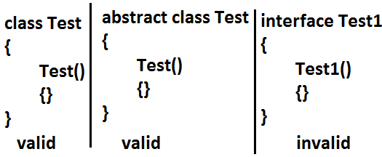

**We can’t create object for abstract class but abstract class can contain constructor what is the need?**

* Abstract class constructor will be executed to perform initialization of child class object.

**Which of the following statement is true?**

1. Whenever we are creating child class object then automatically parent class object will be created.(false)
2. Whenever we are creating child class object then parent class constructor will be executed.(true)

**Example:**

abstract class Parent

{

Parent()

{

System.out.println(this.hashCode());//11394033//here this means child class object

}

}

class Child extends Parent

{

Child()

{

System.out.println(this.hashCode());//11394033

}

}

class Test

{

public static void main(String[] args)

{

Child c=new Child();

System.out.println(c.hashCode());//11394033

}

}

**Case 1:** recursive method call is always runtime exception where as recursive constructor invocation is a compile time error.

**Note:**

**Recursive functions:**

* A function is called using two methods (types).

1. Nested call
2. Recursive call

**Nested call:**

* Calling a function inside another function is called nested call.
* In nested call there is a calling function which calls another function(called function).

**Example:**

public static void methodOne()

{

methodTwo();

}

public static void methodTwo()

{

methodOne();

}

**Recursive call:**

* Calling a function within same function is called recursive call.
* In recursive call called and calling function is same.

**Example:**

public void methodOne()

{

methodOne();

}

**Example:**

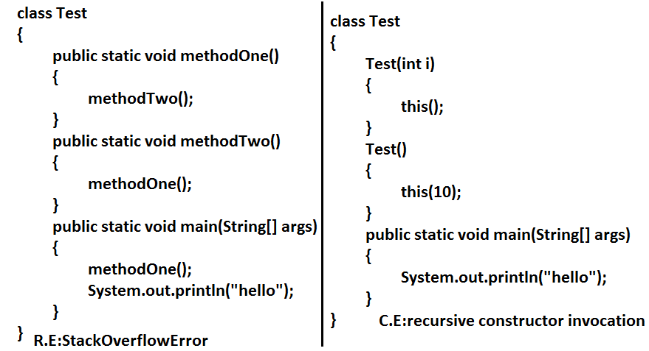

**Note:** Compiler is responsible for the following checkings.

1. Compiler will check whether the programmer wrote any constructor or not. If he didn’t write at least one constructor then compiler will generate default constructor.
2. If the programmer wrote any constructor then compiler will check whether he wrote super() or this() in the 1st line or not. If his not writing any of these compiler will always write (generate) super().
3. Compiler will check is there any chance of recursive constructor invocation. If there is a possibility then compiler will raise compile time error.

**Case 2:**

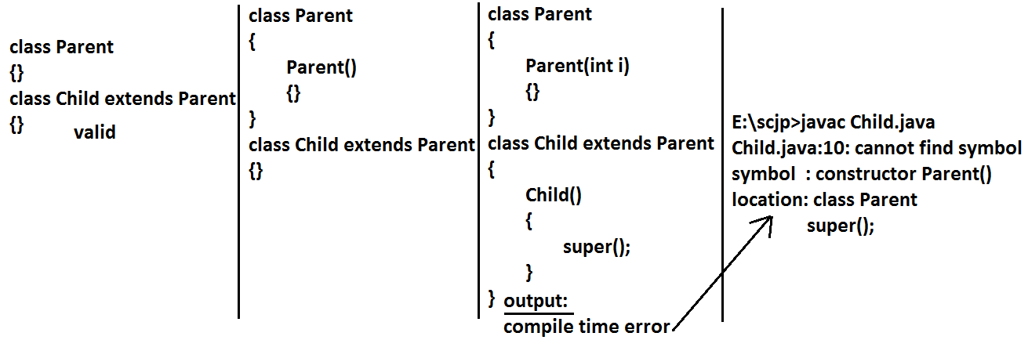

* If the Parent class contains any argument constructors while writing Child classes we should takes special care with respect to constructors.
* Whenever we are writing any argument constructor it is highly recommended to write no argument constructor also.

**Case 3:**

class Parent

{

Parent()throws java.io.IOException

{}

}

class Child extends Parent

{}

**Output:**

Compile time error

* Unreported exception java.io.IOException in default constructor.

**Example:**

class Parent

{

Parent()throws java.io.IOException

{}

}

class Child extends Parent

{

Child()throws Exception

{

super();

}

}

* If Parent class constructor throws some checked exception compulsory Child class constructor should throw the same checked exception (or) its Parent.

**Singleton classes:**

* For any java class if we are allow to crate only one object such type of class is said to be singleton class.

**Example:**

1. Runtime class
2. ActionServlet
3. ServiceLocator

Runtime r1=Runtime.getRuntime();//**getRuntime() method is a factory method**

.................................................

.................................................

Runtime r2=Runtime.getRuntime();

.................................................

.................................................

Runtime r3=Runtime.getRuntime();

System.out.println(r1==r2);//true

System.out.println(r1==r3);//true

**Diagram:**

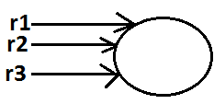

* If the requirement is same then instead of creating a separate object for every person we will create only one object and we can share that object for every required person we can achieve this by using singleton classes. That is the main advantages of singleton classes are Performance will be improved and memory utilization will be improved.

**Creation of our own singleton classes:**

* We can create our own singleton classes for this we have to use private constructor and factory method.

**Example:**

class Test

{

private static Test t=null;

private Test()

{}

public static Test getTest()//getTest() method is a factory method

{

if(t==null)

{

t=new Test();

}

return t;

}

}

class Client

{

public static void main(String[] args)

{

System.out.println(Test.getTest().hashCode());//1671711

System.out.println(Test.getTest().hashCode());//1671711

System.out.println(Test.getTest().hashCode());//1671711

System.out.println(Test.getTest().hashCode());//1671711

}

}

**Diagram:**

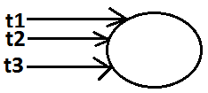

**Note:**

* We can create any xxxton classes like(double ton,trible ton….etc)

**Example:**

class Test

{

private static Test t1=null;

private static Test t2=null;

private Test()

{}

public static Test getTest()//getTest() method is a factory method

{

if(t1==null)

{

t1=new Test();

return t1;

}

else if(t2==null)

{

t2=new Test();

return t2;

}

else

{

if(Math.random()<0.5)

return t1;

else

return t2;

}

}

}

class Client

{

public static void main(String[] args)

{

System.out.println(Test.getTest().hashCode());//1671711

System.out.println(Test.getTest().hashCode());//11394033

System.out.println(Test.getTest().hashCode());//11394033

System.out.println(Test.getTest().hashCode());//1671711

}

}

**Which of the following is true?**

1. The name of the constructor and name of the class need not be same.(false)
2. We can declare return type for the constructor but it should be void. (false)
3. We can use any modifier for the constructor. (false)
4. Compiler will always generate default constructor. (false)
5. The modifier of the default constructor is always default. (false)
6. The 1st line inside every constructor should be super always. (false)
7. The 1st line inside every constructor should be either super or this and if we are not writing anything compiler will always place this().(false)
8. Overloading concept is not applicable for constructor. (false)
9. Inheritance and overriding concepts are applicable for constructors. (false)
10. Concrete class can contain constructor but abstract class cannot. (false)
11. Interface can contain constructor. (false)
12. Recursive constructor call is always runtime exception. (false)
13. If Parent class constructor throws some un-checked exception compulsory Child class constructor should throw the same un-checked exception or it’s Parent. (false)
14. Without using private constructor we can create singleton class. (false)
15. None of the above.(true)

**Factory method:**

* By using class name if we are calling a method and that method returns the same class object such type of method is called factory method.

**Example:**

Runtime r=Runtime.getRuntime();//getRuntime is a factory method.

DateFormat df=DateFormat.getInstance();

* If object creation required under some constraints then we can implement by using factory method.

**Static control flow:**

**Example:**

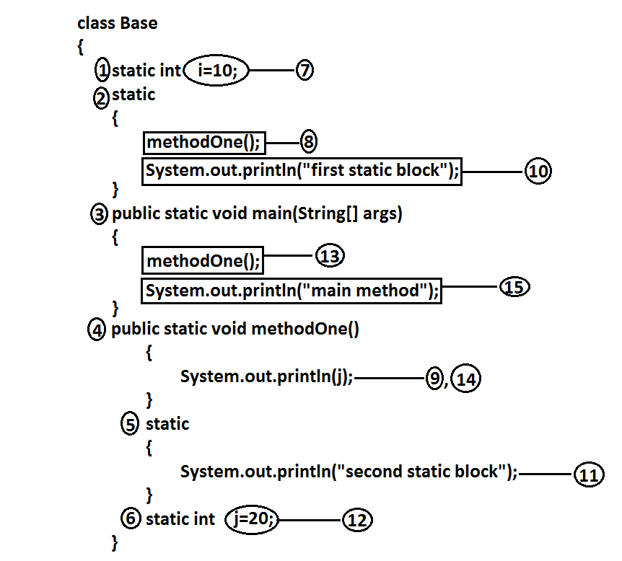

**Analysis:**

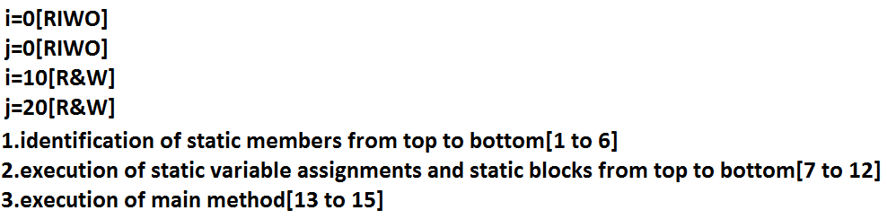

**Output:**

E:\scjp>javac Base.java

E:\scjp>java Base

0

First static block

Second static block

20

Main method

**Read indirectly write only state (or) RIWO:**

* If a variable is in RIWO state then we can’t perform read operation directly otherwise we will get compile time error saying illegal forward reference.

**Example:**

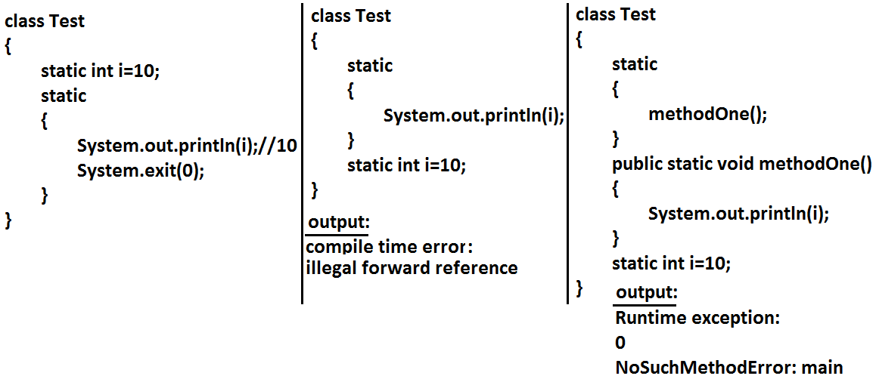

**Example:**

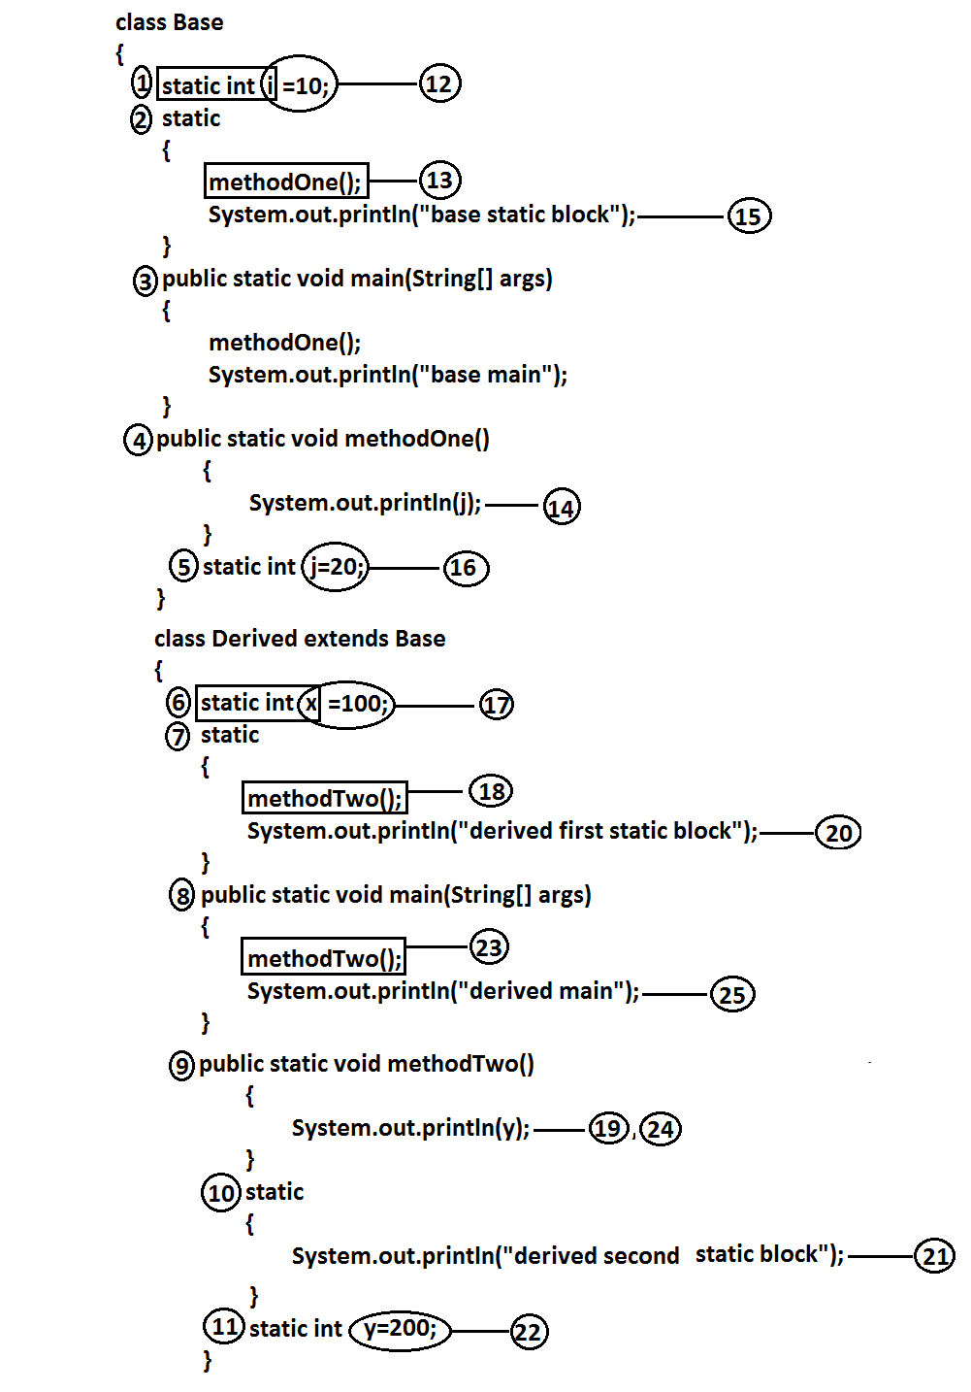

**Analysis:**

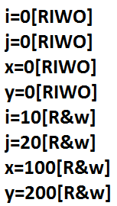

**Output:**

E:\scjp>java Derived

0

Base static block

0

Derived first static block

Derived second static block

200

Derived main

* Whenever we are executing Child class the following sequence of events will be performed automatically.

1. Identification of static members from Parent to Child. [1 to 11]
2. Execution of static variable assignments and static blocks from Parent to Child.[12 to 22]
3. Execution of Child class main() method.[23 to 25].

**Static block:**

* Static blocks will be executed at the time of class loading hence if we want to perform any activity at the time of class loading we have to define that activity inside static block.
* With in a class we can take any no. Of static blocks and all these static blocks will be executed from top to bottom.

**Example:**

* The native libraries should be loaded at the time of class loading hence we have to define that activity inside static block.

**Example:**

class Test

{

static

{

System.loadLibrary("native library path");

}

}

* Every JDBC driver class internally contains a static block to register the driver with DriverManager hence programmer is not responsible to define this explicitly.

**Example:**

class Driver

{

static

{

Register this driver with DriverManager

}

}

**Without using main() method is it possible to print some statements to the console?**

Ans: Yes, by using static block.

**Example:**

class Google

{

static

{

System.out.println("hello i can print");

System.exit(0);

}

}

**Output:**

Hello i can print

**Without using main() method and static block is it possible to print some statements to the console?**

**Example 1:**

class Test

{

static int i=methodOne();

public static int methodOne()

{

System.out.println("hello i can print");

System.exit(0);

return 10;

}

}

**Output:**

Hello i can print

**Example 2:**

class Test

{

static Test t=new Test();

Test()

{

System.out.println("hello i can print");

System.exit(0);

}

}

**Output:**

Hello i can print

**Example 3:**

class Test

{

static Test t=new Test();

{

System.out.println("hello i can print");

System.exit(0);

}

}

**Output:**

Hello i can print

**Without using System.out.println() statement is it possible to print some statement to the console?**

**Example:**

class Test

{

public static void main(String[] args)

{

System.err.println("hello");

}

}

**Instance control flow:**

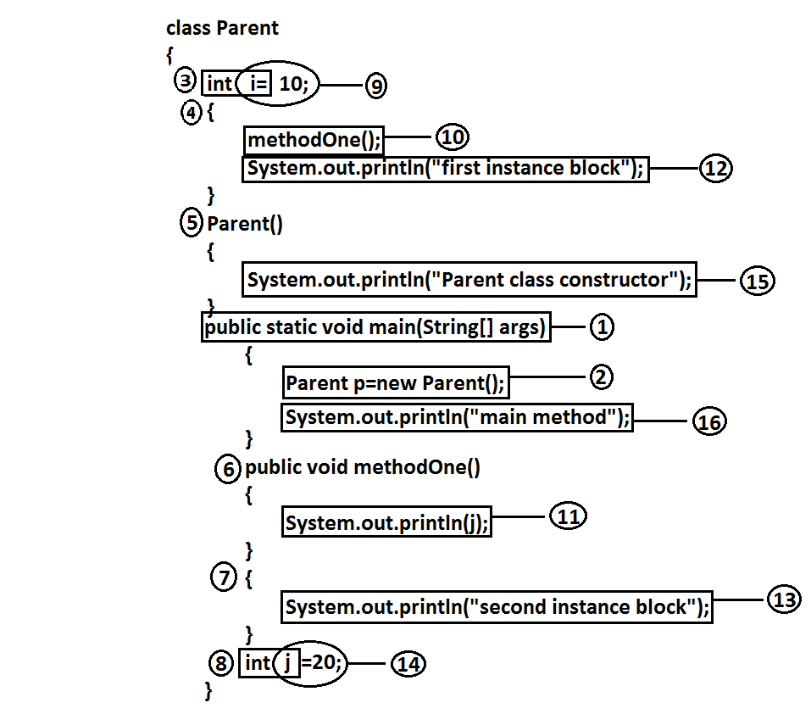

**Analysis:**

i=0[RIWO]

j=0[RIWO]

i=10[R&W]

j=20[R&W]

**Output:**

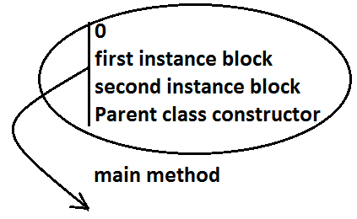

* Whenever we are creating an object the following sequence of events will be performed automatically.

1. Identification of instance members from top to bottom(3 to 8).
2. Execution of instance variable assignments and instance blocks from top to bottom(9 to 14).
3. Execution of constructor.

**Note:** static control flow is one time activity and it will be executed at the time of class loading.

* But instance control flow is not one time activity for every object creation it will be executed.

**Instance control flow in Parent and Child relationship:**

**Example:**

class Parent

{

int x=10;

{

methodOne();

System.out.println("Parent first instance block");

}

Parent()

{

System.out.println("parent class constructor");

}

public static void main(String[] args)

{

Parent p=new Parent();

System.out.println("parent class main method");

}

public void methodOne()

{

System.out.println(y);

}

int y=20;

}

class Child extends Parent

{

int i=100;

{

methodTwo();

System.out.println("Child first instance block");

}

Child()

{

System.out.println("Child class constructor");

}

public static void main(String[] args)

{

Child c=new Child();

System.out.println("Child class main method");

}

public void methodTwo()

{

System.out.println(j);

}

{

System.out.println("Child second instance block");

}

int j=200;

}

**Output:**

E:\scjp>javac Child.java

E:\scjp>java Child

0

Parent first instance block

Parent class constructor

0

Child first instance block

Child second instance block

Child class constructor

Child class main method

* Whenever we are creating child class object the following sequence of events will be executed automatically.

1. Identification of instance members from Parent to Child.
2. Execution of instance variable assignments and instance block only in Parent class.
3. Execution of Parent class constructor.
4. Execution of instance variable assignments and instance blocks in Child class.
5. Execution of Child class constructor.

**Note**:Object creation is the most costly operation in java and hence if there is no specific requirement never recommended to crate objects.

**Example 1:**

public class Initilization

{

private static String methodOne(String msg)

{

System.out.println(msg);

return msg;

}

public Initilization()

{

m=methodOne("1");

}

{

m=methodOne("2");

}

String m=methodOne("3");

public static void main(String[] args)

{

Object obj=new Initilization();

}

}

**Analysis:**

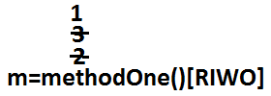

**Output:**

2

3

1

**Example 2:**

public class Initilization

{

private static String methodOne(String msg)

{

System.out.println(msg);

return msg;

}

static String m=methodOne("1");

{

m=methodOne("2");

}

static

{

m=methodOne("3");

}

public static void main(String[] args)

{

Object obj=new Initilization();

}

}

**Output:**

1

3

2

* We can’t access instance variables directly from static area because at the time of execution of static area JVM may not identify those members.

**Example:**

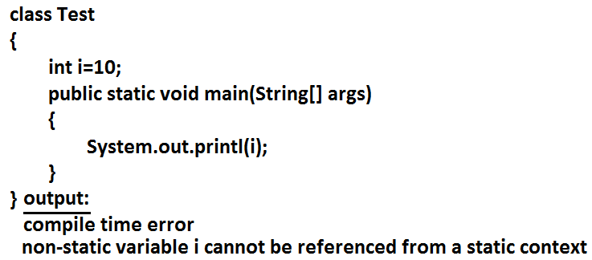

* But from the instance area we can access instance members directly.
* Static members we can access from anywhere directly because these are identified already at the time of class loading only.

**Type casting:**

* Parent class reference can be used to hold Child class object but by using that reference we can’t call Child specific methods.

**Example:**

Object o=new String("bhaskar");//valid

System.out.println(o.hashCode());//valid

System.out.println(o.length());//C.E:cannot find symbol,symbol : method length(),location: class java.lang.Object

* Similarly we can use interface reference to hold implemented class object.

**Example:**

Runnable r=new Thread();

**Type casting syntax:**

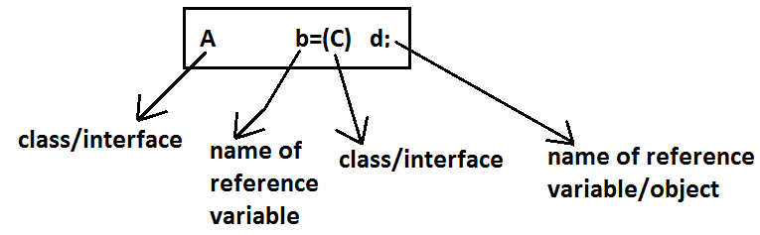

**Compile time checking:**

**Rule 1:** The type of “d” and “c” must have some relationship [either Child to Parent (or) Parent to Child (or) same type] otherwise we will get compile time error saying inconvertible types.

**Example 1:**

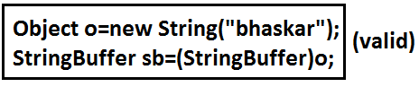

**Example 2:**

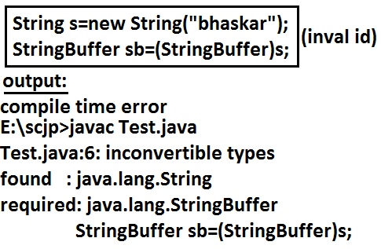

**Rule 2:** “C” must be either same (or) derived type of “A” otherwise we will get compile time error saying incompatible types.

Found: C

Required: A

**Example 1:**

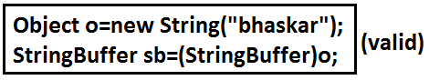

**Example 2:**

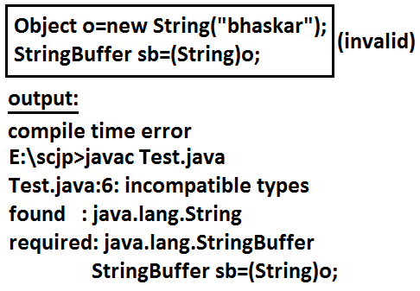

**Runtime checking:**

* The underlying object type of “d” must be either same (or) derived type of “C” otherwise we will get runtime exception saying ClassCastException.

**Example:**

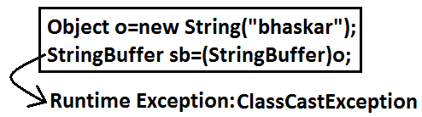

**Diagram:**

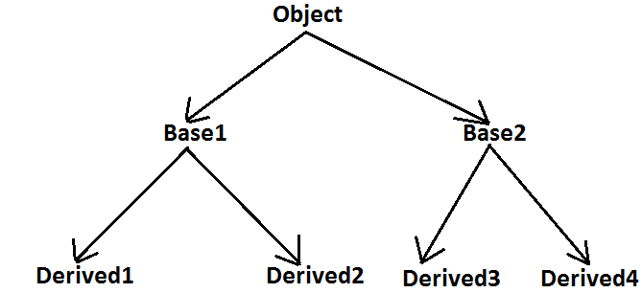

Base1 b=new Derived2();//valid

Object o=(Base1)b;//valid

Object o1=(Base2)o;//invalid

Object o2=(Base2)b;//invalid

Base2 b1=(Base1)(new Derived1());//invalid

Base2 b2=(Base2)(new Derived3());//valid

Base2 b2=(Base2)(new Derived1());//invalid

* Through Type Casting just we are converting the type of object but not object itself that is we are performing type casting but not object casting.

**Example:**

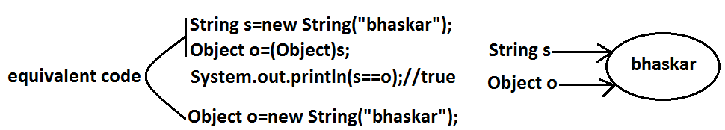

**Example 1:**

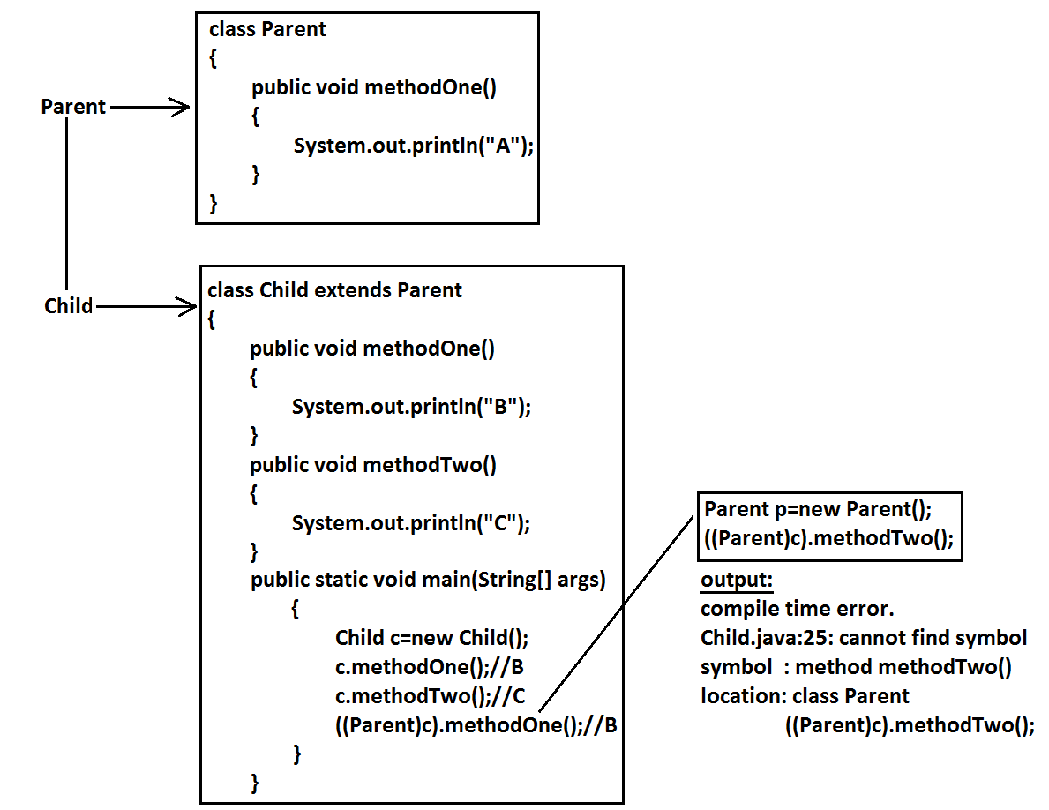

**Example 2:**

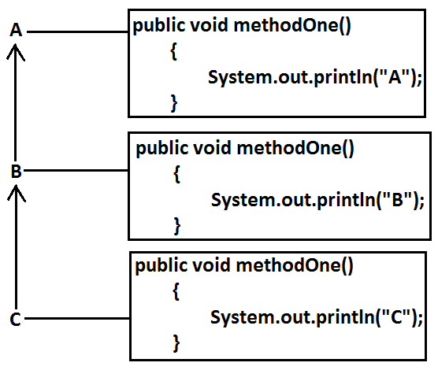

* It is overriding and method resolution is based on runtime object.

C c=new C();

c.methodOne();//c

((B)c).methodOne();//c

((A)((B)c)).methodOne();//c

**Example 3:**

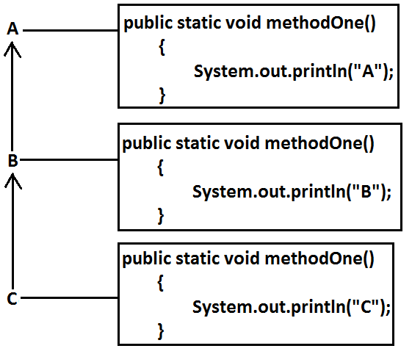

* It is method hiding and method resolution is based on reference type.

C c=new C();

c.methodOne();//C

((B)c).methodOne();//B

((A)((B)c)).methodOne();//A

**Example 4:**

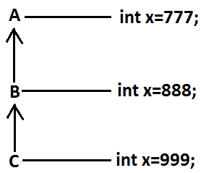

C c=new C();

System.out.println(c.x);//999

System.out.println(((B)c).x);//888

System.out.println(((A)((B)c)).x);//777

* Variable resolution is always based on reference type only.
* If we are changing variable as static then also we will get the same output.

**Coupling:**

* The degree of dependency between the components is called coupling.

**Example:**

class A

{

static int i=B.j;

}

class B extends A

{

static int j=C.methodOne();

}

class C extends B

{

public static int methodOne()

{

return D.k;

}

}

class D extends C

{

static int k=10;

public static void main(String[] args)

{

D d=new D();

}

}

* The above components are said to be tightly coupled to each other because the dependency between the components is more.
* Tightly coupling is not a good programming practice because it has several serious disadvantages.

1. Without effecting remaining components we can’t modify any component hence enhancement(development) will become difficult.
2. It reduces maintainability of the application.
3. It doesn’t promote reusability of the code.

* It is always recommended to maintain loosely coupling between the components.

**Cohesion:**

* For every component we have to maintain a clear well defined functionality such type of component is said to be follow high cohesion.

**Diagram:**

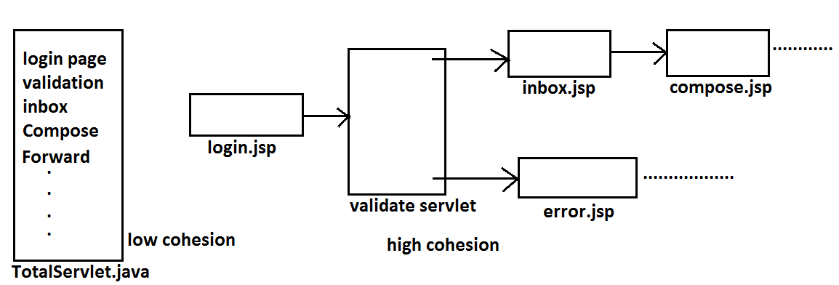

* High cohesion is always good programming practice because it has several advantages.

1. Without effecting remaining components we can modify any component hence enhancement will become very easy.
2. It improves maintainability of the application.
3. It promotes reusability of the application.

**Note:** It is highly recommended to follow loosely coupling and high cohesion.